

VIT BHOPAL UNIVERSITY
School of Computing Science and Engineering
Bhopal-Indore Highway, Kothrikalan, Sehore
Madhya Pradesh - 466114

CSA3006 DATA MINING AND DATA WAREHOUSING

REG.NO : 23BAI10359
NAME : Kislay Anand
BRANCH : CSE(AI & ML)
SEMESTER: Winter Semester 2025-26

INDEX

Ex.NO | DATE | EXPERIMENT NAME | PAGE NO.
1 | 09.01.25 | Exploring WEKA and Building an anonymous Data Warehouse
2 |  | Implementation of several data pre-processing tasks on datasets.
3 |  | Implementation of association rule mining on data sets
4 |  | Implementation of classification techniques: Naïve Baye’s, and SVM on data sets
5 |  | Implementation of regression techniques: linear, logistics and Neural Networks on data sets
6 |  | Implementation of k-means and graph-based clustering techniques on data sets
7 |  | Credit Risk Assessment. Sample Programs using German Credit Data
8 |  | Sample Programs using Hospital Management System
9 |  | Beyond the Syllabus -Simple Project on Data Pre-processing

EXP.NO: 01 | Exploring WEKA and Building an anonymous Data Warehouse
DATE: 09.01.25 | Exploring WEKA and Building an anonymous Data Warehouse

AIM

To implement Decision Tree learning using WEKA and generate a decision tree model for classification.

PROCEDURE

- Open WEKA and click on Explorer.
- Click Open file and load the dataset (.csv or .arff).
- Go to the Preprocess tab and check the attributes.
- Remove unwanted or sensitive attributes if needed.
- Go to the Classify tab.
- Click on Choose → trees → J48 (Decision Tree algorithm).
- Select the class attribute (target variable).
- Click on Start to run the classifier.
- Observe the generated:
- Decision tree
- Accuracy
- Confusion matrix
Save the model if required.

INPUT

A dataset containing attributes and class labels.
Input (anonymous_student_data.arff):
- Age
- Gender
- Department
- CGPA
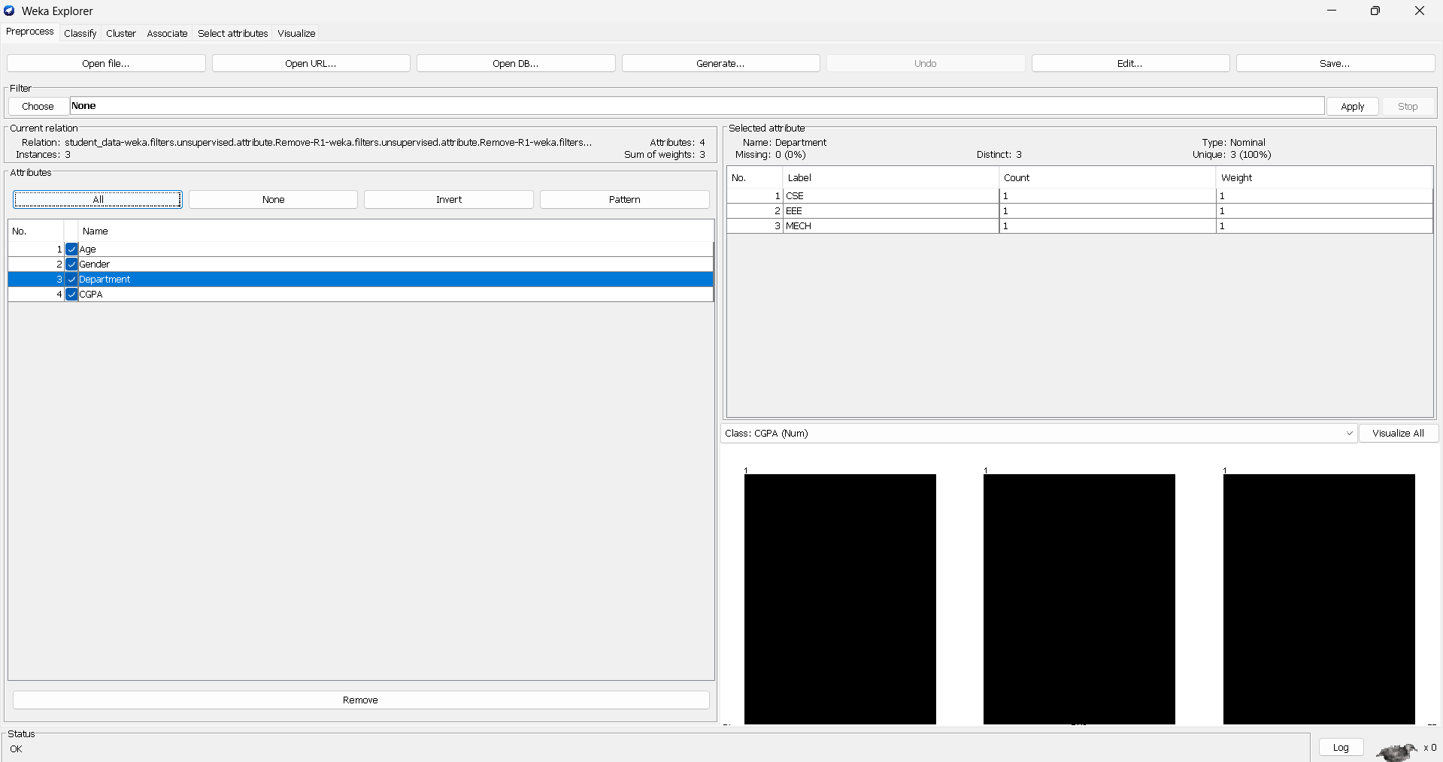

OUTPUT

- A generated Decision Tree model
- Classification accuracy
- Confusion matrix
- Correctly and incorrectly classified instances
(WEKA displays all these after clicking Start)

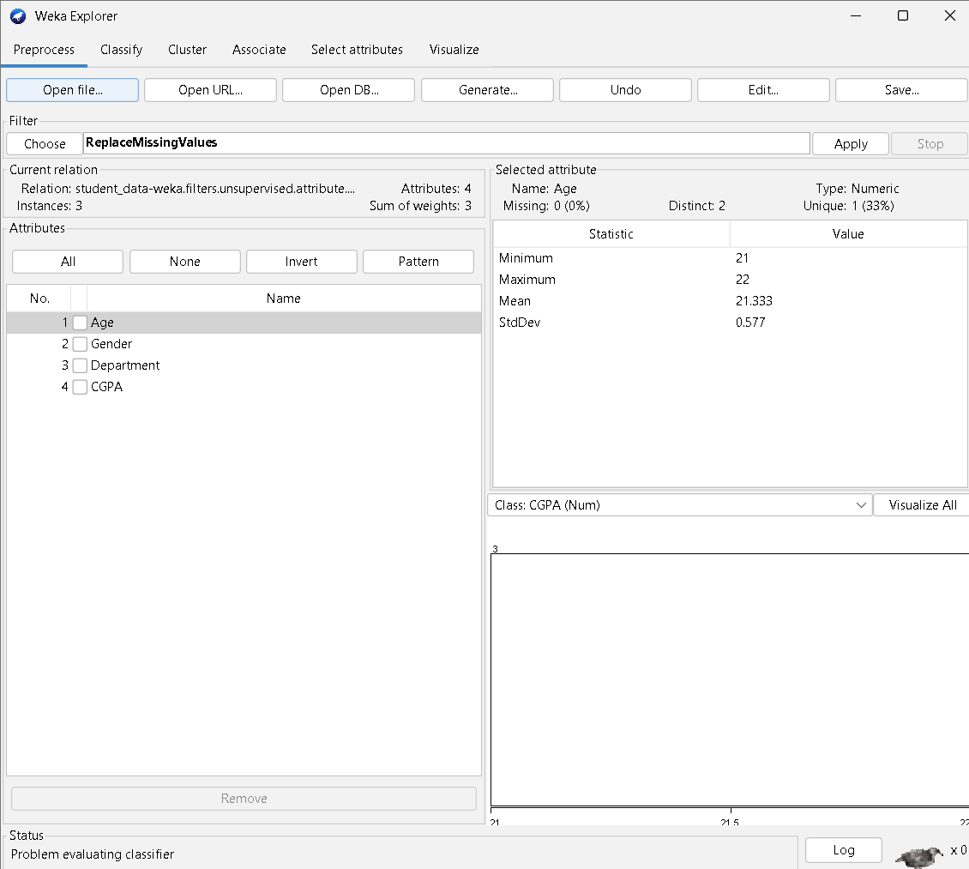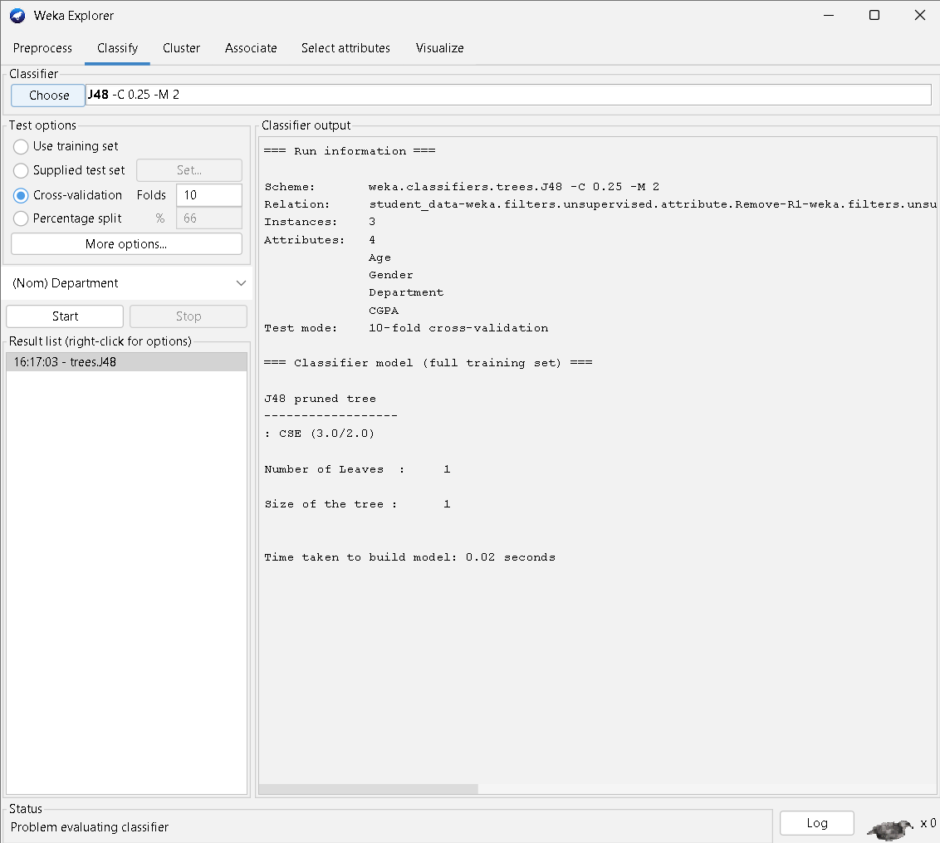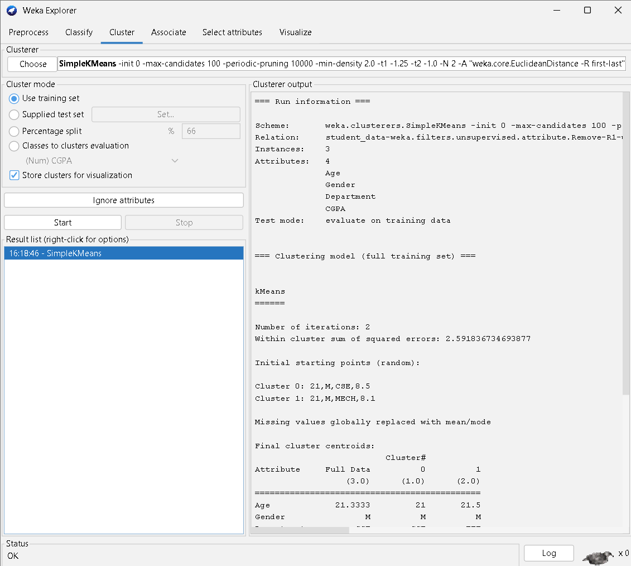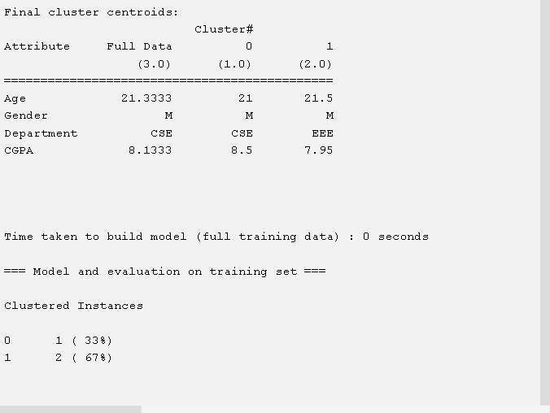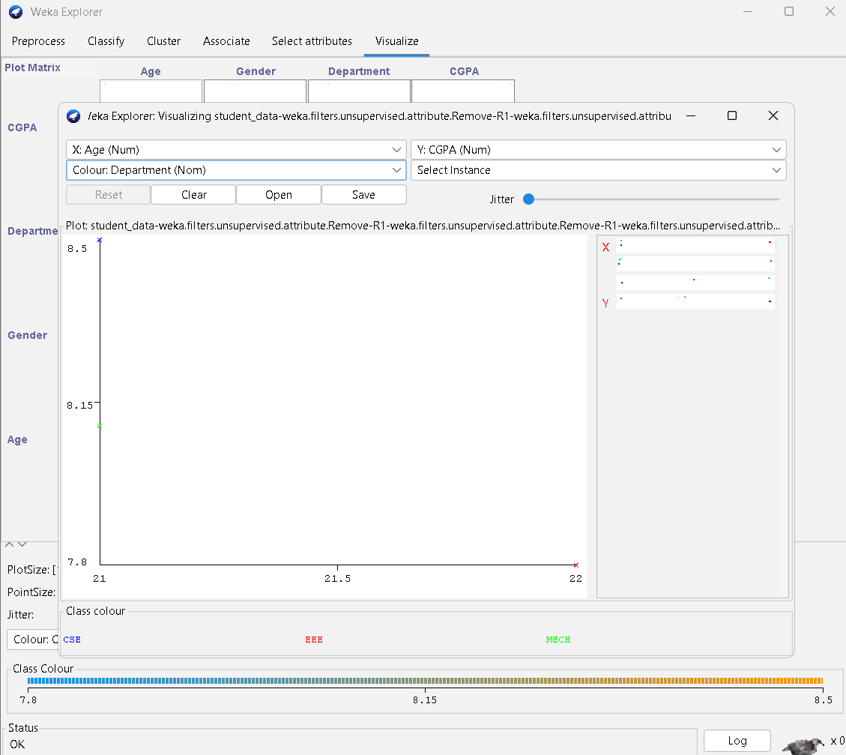

RESULT

Thus, the Decision Tree learning algorithm (J48) was successfully implemented using WEKA and a classification model was generated from the given dataset.

EXP.NO: 02
DATE:

AIM

